**The Imaginary Unit, $i$**

The square root of negative 1 is known as the imaginary number, $i$. The square of this equality produces the real number negative 1.

$$\sqrt{-1}=i → {\left(\sqrt{-1}\right)}^{2}={\left(i\right)}^{2} → -1=i^{2}$$

Example 1: Solve $x^{2}+25=0$

**Complex Numbers**

A complex number is the sum or a real number and an imaginary number. The standard form for a complex number is

$$a+bi$$

where $a$ is the real part and $bi$ is the imaginary part.

Complex numbers can be added/subtracted by performing the addition/subtraction on the real parts and imaginary parts separately:

$$\left(a+bi\right)±\left(c+di\right)=\left(a±c\right)+\left(bi±di\right)=\left(a±c\right)+\left(b±d\right)i$$

Complex numbers can be multiplied using the double distributive property:

$$\left(a+bi\right)\left(c+di\right)=ac+adi+bci+bdi^{2}=ac+\left(ad+bc\right)i-bd=\left(ac-bd\right)+\left(ad+bc\right)i$$

Example 2: $\left(4+3i\right)+(2-5i)$

$\left(4+3i\right)-(2-5i)$

$$\left(4+3i\right)(2-5i)$$

**Quadratic Functions**

The graph of a quadratic function is a U-shaped curve called a **parabola**. One important feature of the graph is that it has an extreme point, called the **vertex**. If the parabola opens up, the vertex represents the lowest point on the graph or the minimum value. If the parabola opens down, the vertex represents the highest point on the graph or the maximum value. In either case, the vertex is a turning point on the graph. The graph is also symmetric with a vertical line drawn through the vertex, called the **axis of symmetry**.

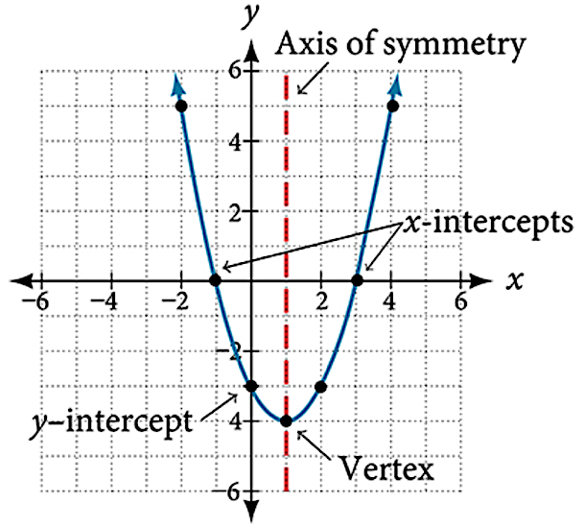

The **general form** of a quadratic function is:

$$f\left(x\right)=ax^{2}+bx+c$$

where $a, b, \text{and} c$ are real numbers and $a≠0.$

* If $a>0$, the parabola opens up
* If $a<0$, the parabola opens down
* The vertex is $\left(-\frac{b}{2a}, f\left(-\frac{b}{2a}\right)\right)$
* The axis of symmetry is $x=-\frac{b}{2a}$
* The zeros or $x$–intercepts are $x=-\frac{b}{2a}±\frac{\sqrt{b^{2}-4ac}}{2a}$

The **vertex form** of a quadratic function is:

$$f\left(x\right)=a{\left(x-h\right)}^{2}+k$$

where $a, h, \text{and} k$ are real numbers and $a≠0$.

* If $a>0$, the parabola opens up
* If $a<0$, the parabola opens down
* The vertex is $(h,k)$
* The axis of symmetry is $x=h$
* The zeros or $x$–intercepts are $x=h±\sqrt{-\frac{k}{a}}$

Example 3: Write the equation of the quadratic function whose graph is given below. Then use your function to determine the zeros of the function.

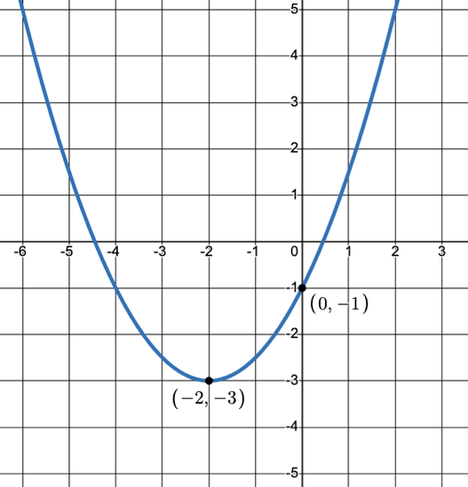

Example 4: Find the vertex of the given quadratic function. Then rewrite the function in vertex form.

$g\left(x\right)=2x^{2}-6x+7$

Example 5: Find the zeros of the given function.

$f\left(x\right)={3x}^{2}+3x+6$

**Complex Conjugate**

The conjugate of the complex number $a+bi$ is $a-bi$. Notice the real part stays the same and the imaginary part becomes its opposite.

In general, the product of conjugates results in opposite terms creating a zero. Here we see this with conjugate complex numbers:

$$\left(a+bi\right)\left(a-bi\right)=a^{2}-abi+abi-b^{2}i^{2}=a^{2}+b^{2}$$

Example 6: Solve $x^{2}-4x+13=0$, then multiply the zeros together.

**Completing the Square**

A process in which we create a perfect square trinomial in order to factor using integers.

Suppose we need to factor: $x^{2}+4x-7$

Since there are no integer factors of negative 7 that have a sum of 4, we add “0”.

$$x^{2}+4x-7=x^{2}+4x+4-7-4$$

Now we can factor the newly created trinomial, and have a new constant after it.

$$\left(x^{2}+4x+4\right)-7-4=\left(x+2\right)\left(x+2\right)-11={\left(x+2\right)}^{2}-11$$

NOTE: This would be the same result if we found the vertex first, and rewrote the function in vertex form.

Example 7: Find the $x$–intercepts of the given function.

$h\left(x\right)=2x^{2}+4x-4$

**Modeling with Quadratics**

In general, when questions ask you to find maximum and/or minimum values, you are being ask to determine the vertex of the quadratic function. However, the vertex has two components (input and output) and so it is crucial to be mindful of what the variables represent.

Example 8: A ball is thrown upward from the top of a 40-foot building at a speed of 80 feet per second. The ball’s height above ground can be modeled by the equation $H\left(t\right)=-16t^{2}+80t+40$

Sketch a visual for the information above.

When does the ball reach its maximum height?

What is the maximum height the ball reaches?

When does the ball hit the ground?

Example 9: A backyard farmer wants to enclose a rectangular space for a new garden within her fenced backyard. She has purchased 80 feet of wire fencing to enclose three sides, and she will use a section of the backyard fence as the fourth side.

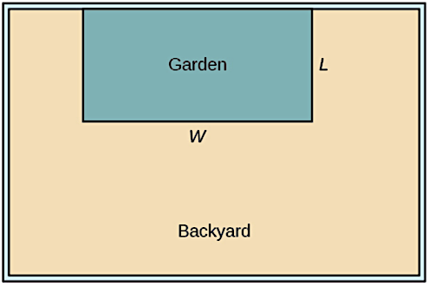

What dimensions should the garden be to maximize the enclosed area?